AWS API Gateway

AWS API Gateway is a managed service used to create and manage APIs that allow applications to communicate securely with backend services like Lambda, EC2, or databases.

An API (Application Programming Interface) is a way for applications to communicate

Lets do a hands-on
Create a serverless API using AWS API Gateway integrated with AWS lambda and access the API using HTTPS endpoint

First lets create a lambda function
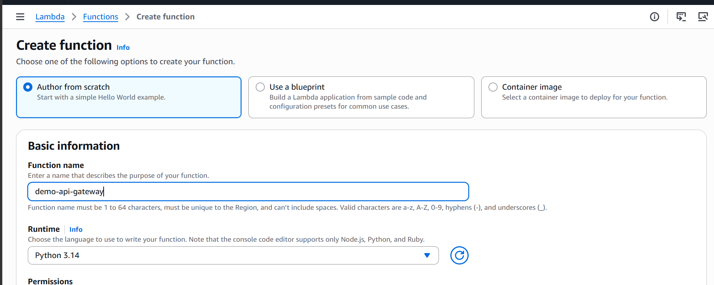

The function is created now
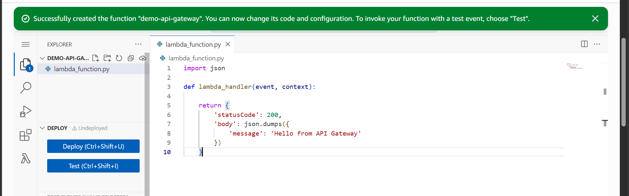
Lets now deploy the code
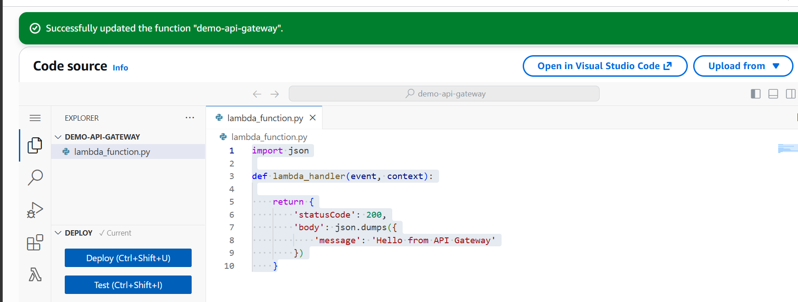

The code is now deployed

Now lets create the API gateway
Search for API Gateway service
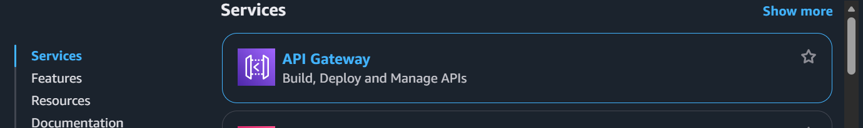
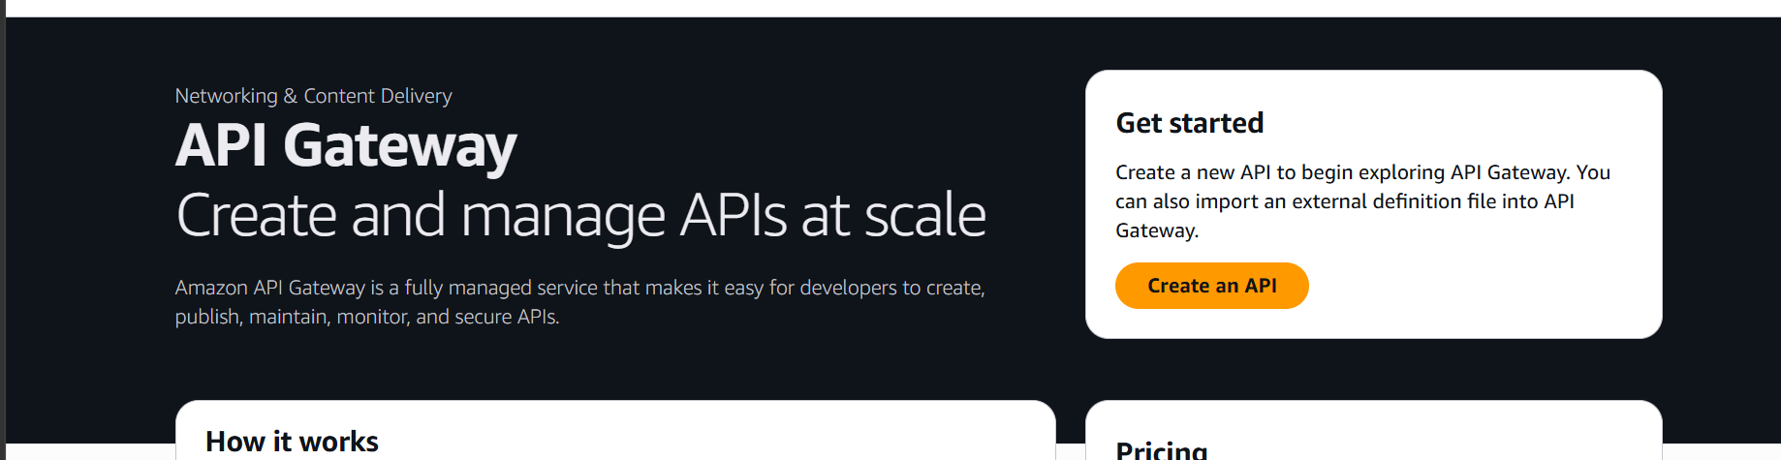

Click on create an API
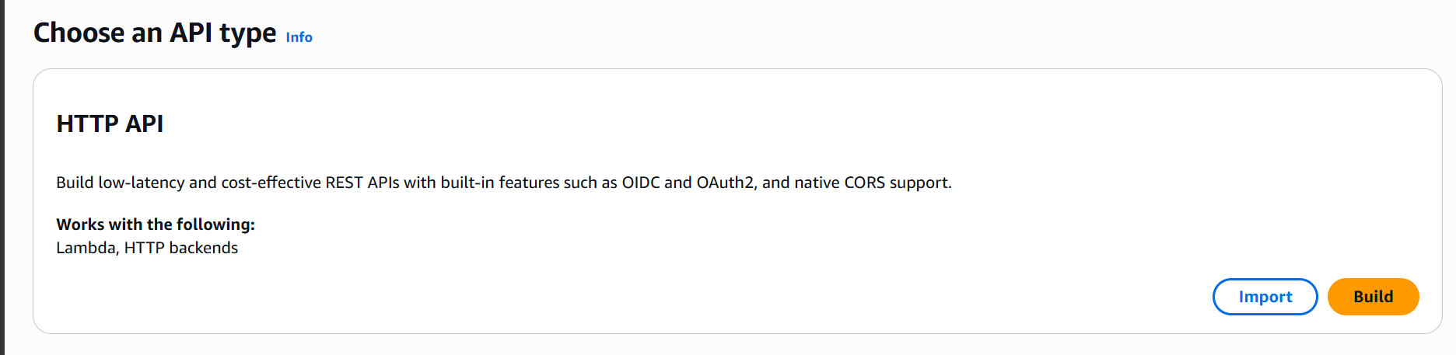
Select HTTP API as API type and click on build
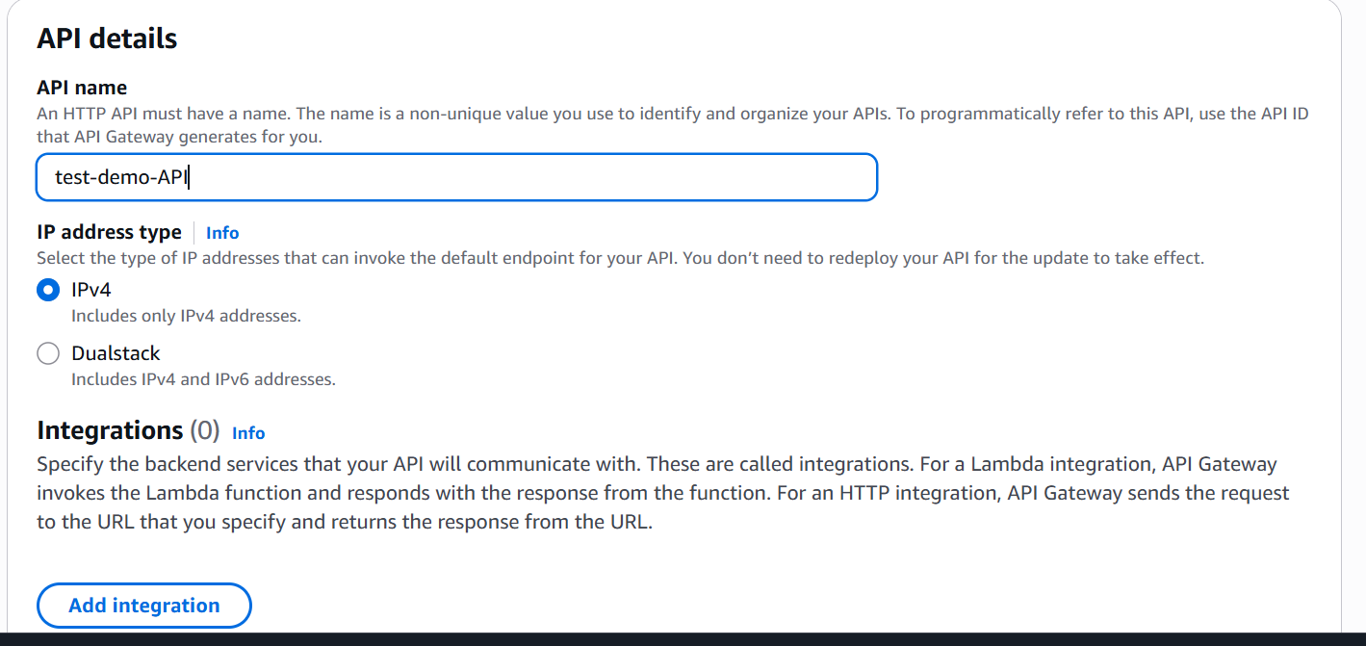

Under integrations
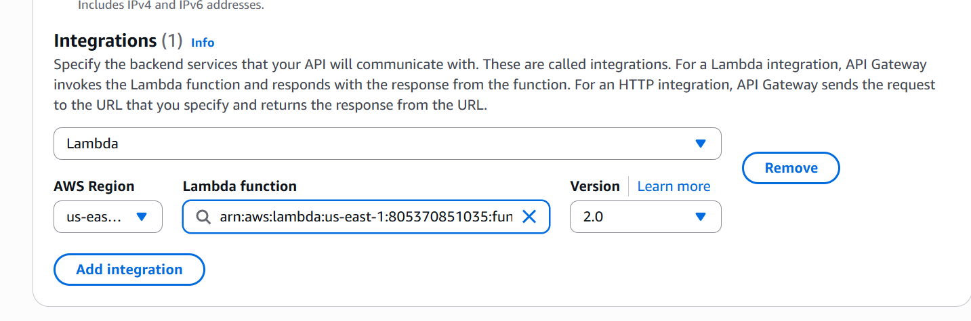

Select lambda and our lambda function
Now configure routes
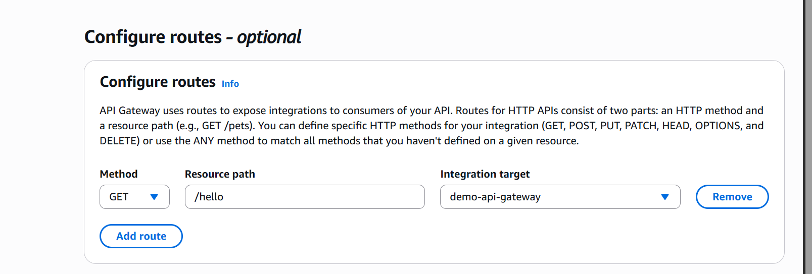

Now lets create our api gateway
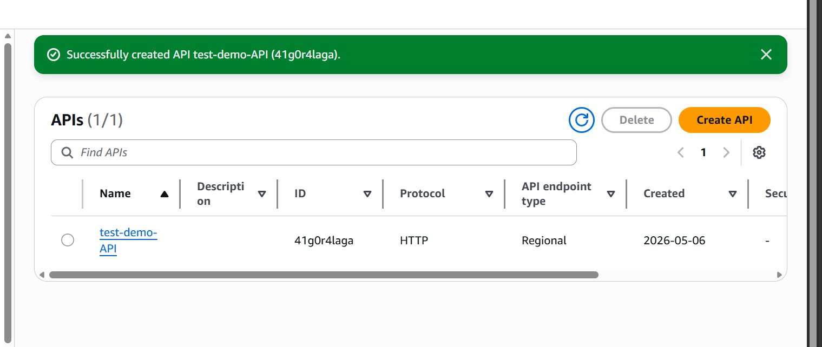

Api is now created
Now when we hit our url we will get this response
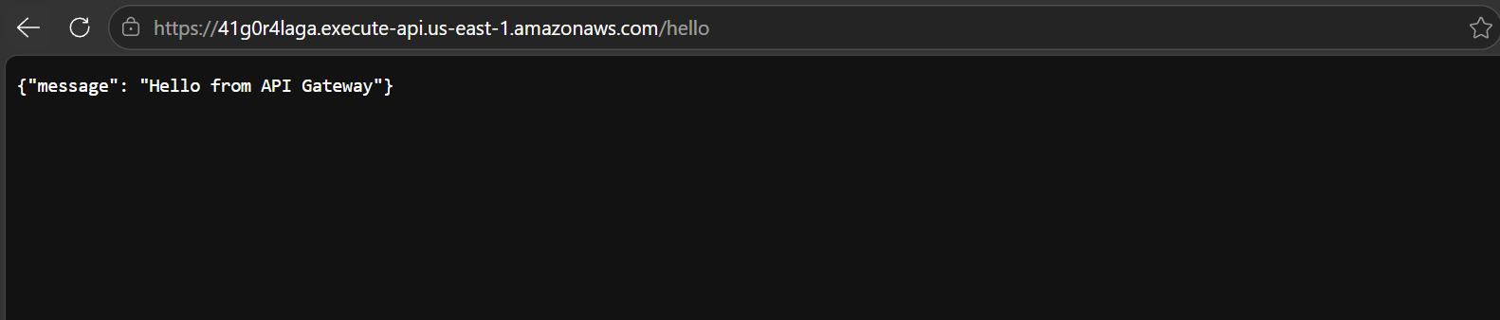

In this task, a serverless API was created using AWS API Gateway and AWS Lambda. API Gateway was used to expose an HTTPS endpoint, and incoming requests were routed to a Lambda function which returned a JSON response.

